1. Answer:
Python differs from statically typed programming languages mainly in how it handles data types, variables, and memory. Python uses dynamic typing, which means the type of a value is determined during program execution rather than being permanently declared for a variable. Python also provides two forms of division, / and //, which differ in how the quotient is calculated and represented.
1. Dynamic Typing and Memory Assignment in Python
In Python, a variable is essentially a name or reference to an object in memory. The object contains the actual value and its type. When a value is assigned to a variable, Python determines the object's type automatically (GeeksforGeeks, 2025).
For example:
x = 10
Here, Python creates or uses an integer object containing 10, and x refers to that object. If we later write:
x = "Hello"
x can now refer to a string object. Therefore, the same variable name can refer to objects of different types during execution. This is called dynamic typing.
In a statically typed language, the type of a variable is normally declared before or during its definition. For example:
int x = 10;
Here, x is declared as an integer, and the language's type system normally prevents assigning a string to it.
Memory assignment
Python uses automatic memory management. The programmer generally does not have to manually allocate and release memory. Python keeps track of objects that are being used and can reclaim memory from objects that are no longer accessible.
Therefore, the main difference is:
- Python: variables refer to objects, and the object's type is determined at runtime.
- Statically typed languages: variables generally have a declared type that is checked by the language's type system.
2. Floating-Point Division /
The / operator performs true division. It calculates the complete mathematical quotient, including the fractional part.
For example: 10 / 3
So, Python produces a floating-point result approximately equal to:
3.3333333333333335
The result is represented as a floating-point value. Because floating-point numbers are stored using a finite binary representation, some decimal values cannot be represented exactly.
For example:
10 / 2
produces:
5.0
The result is still a floating-point value.
3. Floor Division //
The // operator performs floor division. It calculates the quotient and then takes the floor of the result (Behrman, 2021).
For example:
10 // 3
produces:
10 // 3 = 3
The important point is that // is technically floor division, not simply truncation.
For negative numbers:
-10 // 3
The mathematical result is: −3.33333
The floor is: -4
So:
-10 // 3 = -4
4. Difference Between / and //
Aspect | / Floating-Point Division | // Floor Division
Purpose | Calculates true quotient | Calculates floor of quotient
Fractional part | Preserved | Removed according to floor rule
Result with integers | float | Usually int
Example | 10 / 3 = 3.333... | 10 // 3 = 3
Negative example | -10 / 3 = -3.333... | -10 // 3 = -4

Conclusion
Python uses dynamic typing, where variables refer to objects whose types are determined at runtime, and it uses automatic memory management to handle objects in memory. In contrast, statically typed languages normally require variables to have declared types that are checked by the language's type system.
For division, / performs true floating-point division, preserving the fractional part of the quotient, while // performs floor division, giving th e greatest integer less than or equal to the mathematical result. Thus, 10 / 3 produces approximately 3.333, whereas 10 // 3 produces 3.\
References
Behrman, K. (2021). Foundational Python for data science. Addison-Wesley Professional.
GeeksforGeeks. (2025, March 12). Dynamic Typing Python. GeeksforGeeks. https://www.geeksforgeeks.org/python/dynamic-typing-python/

2. Answer:

Short-circuit evaluation is a feature of Python that improves the efficiency of Boolean expressions by stopping the evaluation when the final result is already known. It is especially useful in complex conditions that use logical operators such as and and or.
Short-Circuit Evaluation in if A and B or C:
In Python, the condition:
if A and B or C:
is interpreted as:
if (A and B) or C:
Because the and operator has higher precedence than or. Python evaluates the conditions from left to right (GeeksforGeeks, 2025).
- If A is False, Python skips B because False and B is already False. It then evaluates C.
- If A is True, Python evaluates B.
- If both A and B are True, (A and B) is True, so Python skips C.
- If (A and B) is False, Python evaluates C to determine the final result.
Practical Example:
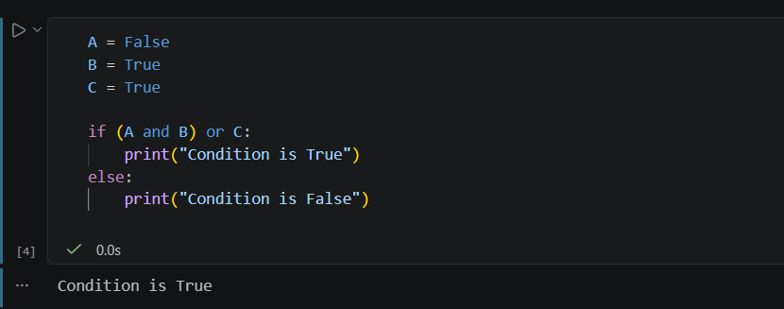
Here, A is False, so Python does not evaluate B. It moves to C, which is True, making the overall condition True.
Arranging Conditions for Execution Speed:
Conditional structures can be arranged to reduce unnecessary operations. With and, it is generally better to place simple and inexpensive conditions that are likely to be false first. With or, it is generally better to place simple and inexpensive conditions that are likely to be true first.
For example:
age = 15
if age >= 18 and expensive_check():
print("Allowed")
Since age >= 18 is False, Python does not execute expensive_check(). This avoids unnecessary processing.

Similarly:
is_admin = True
if is_admin or expensive_check():
print("Access granted")
Since is_admin is True, Python does not execute expensive_check().
Conclusion
Short-circuit evaluation helps Python improve execution efficiency by avoiding unnecessary condition checks and calculations. In if A and B or C, Python evaluates (A and B) first and evaluates C only when necessary. By placing inexpensive and likely-to-determine-the-result conditions first, programmers can reduce unnecessary operations and make conditional structures execute more efficiently.
References
Behrman, K. (2021). Foundational Python for data science. Addison-Wesley Professional.
GeeksforGeeks. (2025b, July 23). Shortcircuit evaluation in Programming. GeeksforGeeks. https://www.geeksforgeeks.org/c/short-circuit-evaluation-in-programming/

